Secure API

Tomer Raitsis & Yossi Elgazari

Table of Contents

Introduction 3

Background 3

Project Design 3

Problem Statement 3

Objectives 3

Methodology 4

Implementation 4

Technologies Used 4

Code Structure 4

Challenges Faced 5

Results and Analysis 5

Improvement Suggestions 5

Conclusion 6

Declaration of GPT Use 6

Introduction

In the rapidly evolving landscape of cybersecurity, the protection of Application Programming Interfaces (APIs) has become increasingly critical. As organizations increasingly rely on microservices architectures and cloud computing, APIs serve as essential conduits for data exchange. However, this reliance exposes sensitive data to potential threats, making it imperative to implement robust security measures. This project aims to establish a secure API framework that adheres to industry best practices, focusing on key security aspects such as authentication, authorization, and input validation. By developing a comprehensive approach to API security, this project not only enhances the security posture of individual applications but also provides a template that can be replicated across various platforms and environments.

Background

APIs (Application Programming Interfaces) are crucial in modern applications, serving as the gateway for data exchange between services. With the rise of cloud computing and microservices architectures, securing these APIs has become a critical concern.

Several industry standards and frameworks have emerged to address API security concerns. OAuth2 is a widely adopted protocol that allows third-party applications to access user resources without exposing sensitive credentials. OpenID Connect builds upon OAuth2, providing an identity layer that enables user authentication. Additionally, Web Application Firewalls (WAFs) serve as protective barriers, filtering and monitoring HTTP traffic to safeguard web applications from malicious attacks.

This project builds on these foundational security measures by creating a secure API framework that integrates JWT for authentication and RBAC for access control. By employing Express.js as the underlying framework, the project aims to establish a standardized approach to API security that can be easily implemented across various applications. The overarching goal is to ensure that sensitive data remains protected from unauthorized access while maintaining the functionality and performance of the API.

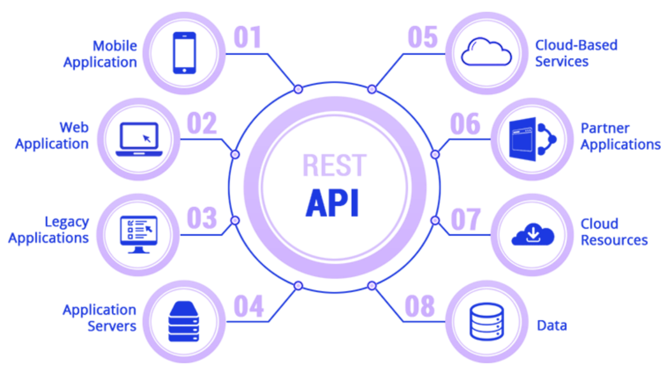

Figure 1: REST API interactions with various applications and services, highlighting the central role of APIs in modern architectures.

## Importance of HTTPS in API Security

As APIs often handle sensitive data, ensuring secure communication between clients and servers is paramount. HTTPS (Hypertext Transfer Protocol Secure) plays a critical role in this by encrypting the data exchanged between the client and the server. This encryption helps prevent man-in-the-middle attacks, where an attacker could intercept or alter the communication. HTTPS not only protects data integrity and confidentiality but also enhances user trust by signaling that the connection is secure.

How HTTPS Ensures Secure Communication: HTTPS operates by establishing a secure encrypted connection between the client and server. This process begins with a TLS (Transport Layer Security) handshake, where the client and server exchange cryptographic keys. The server presents a digital certificate, which the client verifies to ensure the server's identity. Once the handshake is complete, all data transmitted between the client and server is encrypted, preventing unauthorized access, tampering, or eavesdropping. This process is crucial for protecting sensitive data, such as authentication tokens and user information, during API transactions.

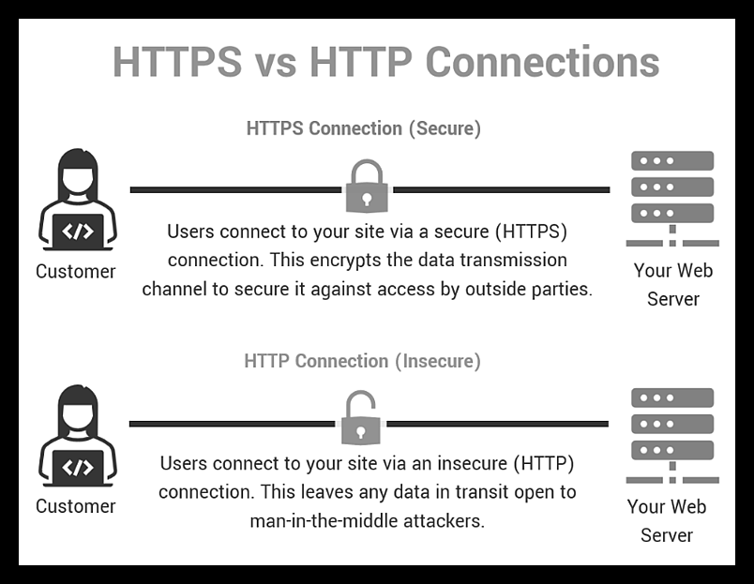

Figure 3: HTTPS vs HTTP Connections comparison

Project Design

## Problem Statement

APIs are vulnerable to various security threats such as unauthorized access, data breaches, and injection attacks. This project aims to mitigate these risks by developing a secure API framework that incorporates industry best practices for authentication, authorization, and input validation.

## Objectives

The primary objectives of this project include:

1. Authentication: Implementing token-based authentication using JWT to ensure that only authorized users can access the API. This mechanism provides a secure method for verifying user identities while minimizing the risk of credential exposure.
2. Authorization: Establishing RBAC to restrict access to specific API endpoints based on user roles. This ensures that sensitive operations are only accessible to privileged users, thereby reducing the risk of unauthorized actions.
3. Input Validation: Implementing robust input validation mechanisms to prevent common vulnerabilities such as SQL injection and cross-site scripting (XSS). By validating user input, the project aims to enhance the overall security of the API.
4. Secure Communication: Ensuring that all data exchanged between clients and the server is encrypted using HTTPS. This protects against man-in-the-middle attacks and ensures the confidentiality of sensitive information.
5. Security Measures: Implementing additional security measures such as rate limiting, logging, and monitoring to protect against abuse and provide visibility into API usage. These measures are essential for maintaining the integrity and security of the API.

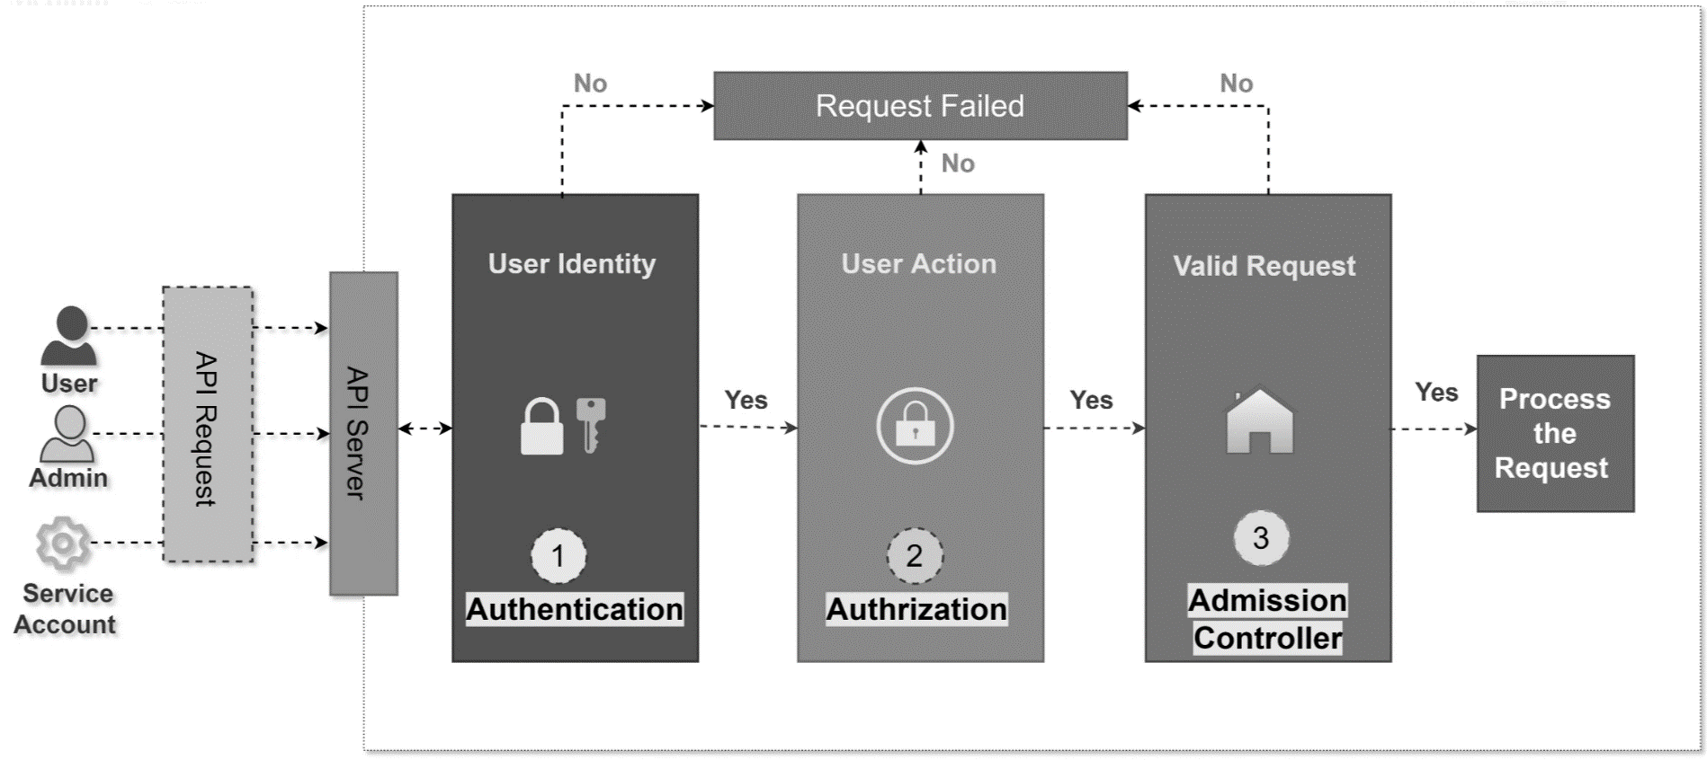

Figure 2: Flow of API requests through authentication, authorization, and admission control.

## Methodology

The project was designed using a modular approach, allowing for flexibility and scalability. Each component of the API is organized into separate controllers that handle different aspects of functionality, such as user management and role management. The choice of Express.js as the framework was driven by its lightweight nature and ease of integration with security middleware, enabling rapid development and deployment.

The database schema was designed using Mongoose, an Object Data Modeling (ODM) library for MongoDB. This approach allows for the definition of schemas and custom validation functions, ensuring data integrity and consistency. The project also emphasizes the importance of thorough testing to validate the security and functionality of the API. By adopting a test-driven development approach, the project aims to identify and address potential vulnerabilities early in the development process.

Implementation

## Technologies Used

The implementation of the secure API framework leverages several key technologies:

Express.js: A fast and minimalist web framework for Node.js, used to handle routing and middleware integration. Its flexibility allows for easy customization of the API.

Mongoose: An ODM library for MongoDB that simplifies database interactions and schema definitions. Mongoose enables the implementation of custom validation functions, enhancing data integrity.

JWT: JSON Web Tokens are employed for secure token-based authentication, providing a reliable method for verifying user identities without exposing sensitive credentials.

Bcrypt: A library used for hashing passwords, ensuring that user credentials are stored securely and minimizing the risk of credential theft.

CORS: Cross-Origin Resource Sharing is implemented to allow restricted resources on a web page to be requested from another domain, ensuring secure interactions between different services.

Logging: The morgan library is utilized to log HTTP requests and responses, providing visibility into API usage and potential security issues.

HTTPS: All data exchanged between clients and the server is encrypted using HTTPS, protecting against interception and ensuring the confidentiality of sensitive information.

Express Rate Limit: Middleware for rate limiting incoming requests, helping to protect against denial-of-service attacks and ensuring fair usage of the API.

## Code Structure

App (`app.js`): Configures and initializes the routes, applying middleware functions for security checks and role-based access control.

Server (`server.js`): Sets up the Express server with necessary configurations such as CORS, logging, rate limiting, and HTTPS. It also handles the connection to the MongoDB database.

dbSchema.js: Defines the schema for user data, including custom validation for email and password formats.

Controllers: Implement logic for different roles and handle API requests, ensuring that security checks are applied consistently across endpoints.

Middlewares: Responsible for input validation, JWT verification, and role-based access checks, ensuring that only authorized users can perform specific actions.

Test Suite (`routes.test.js`): Contains tests to verify the functionality and security of the API endpoints.

## Challenges Faced

Throughout the development of the secure API framework, several challenges emerged that required careful consideration and problem-solving. One of the primary challenges was ensuring the seamless integration of JWT-based authentication with the RBAC system. The complexity of managing different user roles, such as Admin, Supervisor, and User, necessitated a robust access control mechanism to enforce security across various endpoints.

Another significant challenge involved implementing secure input validation to prevent injection attacks. This required a thorough understanding of potential attack vectors and the development of comprehensive validation mechanisms to mitigate risks effectively. Balancing security with performance also posed a challenge, as the implementation of rate limiting and logging needed to be optimized to avoid degrading the API's performance.

Finally, thorough testing was essential to validate the functionality and security of the API across different user roles. Writing and executing comprehensive test cases ensured that all security mechanisms functioned as expected, providing confidence in the API's resilience against potential threats.

Results and Analysis

The secure API was successfully implemented with all endpoints protected by JWT-based authentication and RBAC. The logging mechanism provided detailed insights into API usage, helping to identify potential security threats and ensuring that the API operated within expected parameters.

The rate limiting effectively prevented abuse, while HTTPS ensured that all data exchanged between clients and the server was encrypted, protecting against man-in-the-middle attacks. The performance of the API remained within acceptable limits, even with the added security layers.

Key insights gained include the importance of a layered security approach, where multiple security measures work together to provide robust protection. The project also highlighted the necessity of thorough testing, particularly in scenarios involving different user roles and access levels.

Improvement Suggestions

Enhanced Encryption: Implementing additional encryption for sensitive data stored in the database (e.g., using AES encryption) could provide an extra layer of protection in the event of a database breach.

Dynamic Role Management: Adding a dynamic role management system would allow administrators to create, modify, and delete roles without requiring code changes, providing greater flexibility in managing user access.

API Versioning: Introducing API versioning would ensure backward compatibility and allow for the incremental introduction of new features without disrupting existing clients.

Automated Security Scans: Integrating automated security scans into the CI/CD pipeline would help identify and address potential vulnerabilities early in the development process. This would enhance the overall security posture of the API by ensuring that security best practices are consistently applied.

These improvements would enhance the API's security, flexibility, and maintainability, making it better suited to handle evolving security threats and changing business requirements.

Conclusion

This project successfully implemented a secure RESTful API that adheres to industry best practices for authentication, authorization, and input validation. The effective use of JWT for token-based authentication, combined with the implementation of RBAC to control access, ensures that sensitive operations are restricted to authorized users. Additionally, the integration of input validation mechanisms helps prevent common vulnerabilities, reinforcing the API's security.

The proposed improvements, including enhanced encryption, dynamic role management, API versioning, and automated security scans, could further bolster the API's security and flexibility. Overall, this project represents a valuable contribution to the field of cybersecurity, providing a comprehensive framework for securing APIs and protecting sensitive data.

References

1. "Kubernetes RBAC Essentials: How to Enable and Manage Access." (2024). Security Boulevard. [https://securityboulevard.com/2024/05/kubernetes-rbac-essentials-how-to-enable-and-manage-access/.](https://securityboulevard.com/2024/05/kubernetes-rbac-essentials-how-to-enable-and-manage-access/)
2. "Kubernetes RBAC Best Practices." (2024). Wiz Academy. <https://www.wiz.io/academy/kubernetes-rbac-best-practices.>
3. “Web API Security Vulnerabilities and Mitigation Mechanisms: A Systematic Mapping Study” (2021). International Conference in Software Engineering Research and Innovation: <https://ieeexplore.ieee.org/stamp/stamp.jsp?tp=&arnumber=9653437>
4. “API based Security solutions for Communication among Web Services” (2013). h International Conference on Advanced Computing: <https://ieeexplore.ieee.org/stamp/stamp.jsp?tp=&arnumber=6922014>

Declaration of GPT Use

In the preparation of this report, the assistance of GPT-4 was utilized to help structure the report, refine content, and generate suggestions for improvements. This AI assistance was employed to enhance the clarity and completeness of the report, ensuring that it meets the requirements and standards expected in the field of cybersecurity.



Chat doc attached: